Chapter 3

Research Methodology

Method of Research

Descriptive research methodology was used for this study to conduct the data gathering. Descriptive research describes the data and the characteristics of the population or phenomenon being studied. Descriptive research is mainly done when a researchers wants to gain a better understanding of a topic.

This study utilizes the descriptive method research. As widely accepted, the descriptive method of research is a fact – finding study that involves adequate and accurate interpretation of finding. Descriptive research describes a certain present condition. Relatively, the method is appropriate to this study since it aims to describe the present condition of technical analysis. The technique that was used under descriptive method is the normative survey approach and evaluation, which is commonly used to explore opinions according to respondents that can represent a whole population. The survey is appropriate in this study because it enables the researcher in formulation of generalization specially, two types of direct – date surveys are included in this study. This is a questionnaire survey.

Population, Sample Size and Sampling Techniques

The main respondents of this study are the students and teachers of Cainta Catholic College. The respondents will be given a survey/questionnaire. Furthermore, to obtain accuracy on their responses, the system will be presented to the respondents before writing their responses to the questionnaire. The sampling technique used in this study was Purposive Sampling. The researcher chooses the sample based on who they think would be appropriate for this study. This is used primarily when there are a limited number of people that have expertise in the area being researched.

Description of Respondents

The respondents of the study are the students and teachers in secondary and tertiary level of Cainta Catholic College. The proponents will be able to get the total number of students and teachers which are 4476 and only 501 respondents will be chosen to answer the questionnaires.

Respondents of the Study

The main respondents of this study are the students and teachers of Cainta Catholic College.

The researchers will be using the measure of central tendency to obtain descriptive shorthand of the entire data and describe the population where the responses were gathered. It will determine the average value of responses the respondents will give.

Description of Respondents

The study involved the Grades School, High School and College Students and Teachers of Cainta Catholic College.

|  |  |  |  |
| --- | --- | --- | --- |
|  | Respondents | Frequency | Percentage |
| Grade School | 1,541 | 132 | 26.3% |
| High School | 1,705 | 146 | 29.1% |
| College | 1,027 | 88 | 17.6% |
| Teachers | 203 | 135 | 27.0% |
| Total | 4,476 | 501 | 100% |

Table 1.0 Description of Respondents

Table 1.0 shows the respondents from Grade School, High School, College students and Teachers respondents. Using the stratified random sampling technique, to come up with 1,541 Grade School, this is 26.3% of the respondents. To come up with 1,705 High School, this is 29.1% of the respondents. To come up with 1,027College, this is 17.6% of the respondents. To come up with 203 Teachers, this is 27.0% of the respondents. The total respondents are 4,476 which is 100%.

Research Instruments

The following instruments will be used by the researchers in conducting the study. The proponents have to gather through survey / questionnaire with the following:

1. Below is the Lickert Scale that the researchers will be using in the survey questionnaire of this study.
2. To know the demographic profile of the respondents of Cainta Catholic College in terms of age and grade level.
3. To evaluate the performance of the traditional English grammar teaching and proposed system in terms of security, user-friendly, security, efficiency, and accuracy.
4. To learn the significance difference between the performance of traditional English grammar teaching and proposed system.

Listed below is the scale that the researchers will be using:

Lickert Scale Range Verbal Interpretation

5 4.20 – 5.00 Strongly Agree

4 3.40 – 5.00 Agree

3 2.60 – 3.39 Fair

2 1.80 – 2.59 Disagree

1 1.00 – 1.79 Strongly Disagree

Data Gathering Procedure

In this study, researchers used instruments in gathering data such as observing method, questionnaire method, and document, internet and library research method. This method of searching information will help to carry out the statement of the problem and the objectives.

Internet Research

The researchers used the internet to get valuable information to compute this study. It is a powerful research tool created which can provide different related literatures about the study.

Document Review

The researchers used a document review that contains important information such as scholarly journal and electronic documentation that will be an important contribution that will serve as a guideline in the design and development of the Learn English Grammar E- Learning System.

Library Research

Data mining with the user of library research can help the researcher in gathering data from already tabulated sources to give validity to this study and further strengthen the foundation of this study. Library research can provide valuable and useful material that came in handy for the research in case some important information needed was not readily available on the internet.

Observation Method

This method will observe only something related to research. Base on the study, observation of the research of the researchers helps to give idea what is something wrong and what they need to do.

Validation of the Instrument

To be able to determine the demographic profile of the students and teachers in terms of age and year level, to evaluate the Learn English Grammar E – Learning System in terms of security, efficiency, reliability, and accuracy; and to determine the significant differences between the performance of traditional English grammar teaching and proposed system, the following procedures were followed:

1. The researchers gave the survey questionnaire to the Grades School, High School and College students and Teachers of Cainta Catholic College and let them answer it without time constrain.
2. Once the questionnaires were gathered, the responses were tabulated and interpreted with the use of the different statistical treatment.

Statistical Treatment of Data

A part of the population is examined as representative and approximation of the whole to obtain the necessary information drawing valid inferences or generalizations based on careful observation of variables to produce accurate results.

1. The formula for Sample size is :

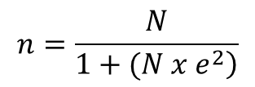

Where:

n = sample size

N = population size

e = margin of error (1%)

1. The percentage formula is used to properly present the proportion of the respondent’s data. The formula for the percentage is :

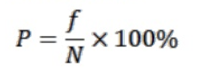

Where:

P = percentage

F = frequency

N = population size

The researcher will be using the measure of central tendency to obtain descriptive shorthand of the entire data and describe the population where the responses were gathered. It will determine the average value of response the respondents will give.

1. The statistical formula for the weighted mean is given by the formula:

TWF

Wm = --------

N

Where:

Wm = Weighted Mean

TWF = Total of the Production of the Weights Multiplied by their corresponding frequencies

N = Numbers of Rates or Total Frequency

1. In testing the hypothesis t-test was used by the researchers. The formula t-test is given below:

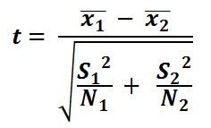

Where:

t = t-test value

first mean.PNG= mean of the first sample

second mean.PNG= mean of the second sample

S1 = variance of the first sample

S2 = variance of the second sample

N1 = number of cases in the first sample

N2 = number of cases in the second sample

T-test used to compare two different set of values. It is generally performed on small set of date. T-test is generally applied to normal distribution which has a small set of values. This test compares the mean of two samples. T-test uses means and standard deviation of two samples to make a comparison.

Ranking data will also be used to present the ranking of the frequency and percentage of the respondent’s data. Ranking the data involves putting the value in numerical order and then assigning new values to denote when in ordered set they fall.

Software Engineering Model

This study used the Software and Systems Requirements Engineering Methodology in the design and requirements. The researcher used the Scrum Software Development Cycle.

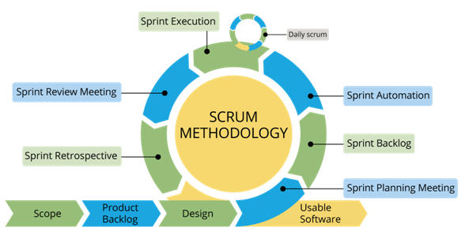

Figure 1.1 Software Engineering Model

Procedures:

* Scrum starts with a Product Owner. This is the person who represents the final user’s best interest, and has the authority to say what goes into the final product.
* That Product Owner is in charge of making the Backlog, a list of tasks and requirements the final product needs. Here’s an important part: The backlog MUST be prioritized. That’s the job of the Product Owner.
* Next up is the Sprint. A Sprint is a predetermined timeframe within which the team completes sets of tasks from the Backlog. The length of time depends on the needs of the team, but two weeks is pretty typical.
* Teams meet every day to give progress updates in the Daily Scrum. Many people also call these “Daily Stand-Ups.”
* Each Sprint ends with a review, or Retrospective, where the team reviews their work and discusses ways to improve the next Sprint.

Development Tools

|  |  |
| --- | --- |
| Specification | Classification |
| Pentium 4 class processor or Above | Processor |
| 1Gb of RAM or Above | Ram |
| 5 gigabytes(Gb) on installation drive, which Includes 1Gb on system drive | Hard Disk |
| CD ROM Drive | 52 X CD ROM Drive |

Table 1.1 Hardware Specifications

Table 1.1 above shows the hardware specification needed to support new system.

|  |  |
| --- | --- |
| Specification | Classification |
| Sublime Text 2 | Code Editor |
| Adobe Photoshop CS6 | Photo Editor |
| JCpicker | Color Picker |
| XAMMP | Database Management System |

Table 1.2 Software Specifications

Table 1.2 above shows the software specification needed to support new system